Name: CHANAKYALINK
githubUrl: https://github.com/Priyadharshinijutta/chanakyalink_75.git

Description:
ChanakyaLink is a custom master-slave communication protocol developed for defence and mining applications that require secure, reliable, deterministic, and time-synchronized communication. Unlike conventional protocols such as SPI and I²C, it emphasizes delay-based execution, controlled command verification, and safety-critical operation. The protocol allows a master controller to communicate with multiple slave nodes through structured communication frames containing the slave ID, command, delay value, and checksum for error detection, where each slave verifies the received data and executes the command only after the specified delay interval.

Functional requirements
Functional Requirements for ChanakyaLink Protocol
Authentication & Device Validation
• Unique master and slave device identification using Slave ID
• Command authentication before execution
• Verification of communication frames using checksum/error detection
• Unauthorized device access prevention
• Secure master-to-slave communication control

Master–Slave Communication Management
• Support communication between one master and multiple slave nodes
• Structured frame transmission containing Slave ID, command, delay, and checksum
• Reliable command delivery from master to target slave
• Slave acknowledgment and response handling
• Synchronized communication between connected nodes
Deterministic & Time-Synchronized Execution
• Delay-based command execution mechanism
• Execution of commands only after specified delay interval
• Accurate timing synchronization between master and slaves
• Deterministic communication for safety-critical operations
• Support for real-time control applications
Error Detection & Reliability
• Checksum-based frame validation
• Detection of corrupted or incomplete frames
• Command rejection on checksum mismatch
• Reliable retransmission support for failed communication
• Fault-tolerant communication handling
Security & Safety Control
• Controlled command verification before execution
• Protection against accidental or unauthorized command execution
• Safe operation in defence and mining environments
• Secure handling of critical control instructions
• System integrity monitoring during communication
Performance Optimization
• Low-latency command transmission
• Optimized communication for deterministic behaviour
• Efficient frame structure for reduced overhead
• Reliable operation in harsh industrial environments
• High communication stability under continuous operation
Frame Structure & Packet Handling
• Fixed and well-defined communication frame format
• Support for command, data, acknowledgment, and control packets
• Frame sequence numbering for packet tracking
• Start and stop bit identification for frame synchronization
• Priority-based packet handling for critical commands

Delay & Scheduling Management
• Configurable delay intervals for each command
• Scheduled execution of time-sensitive operations
• Support for periodic and one-time command execution
• Delay timer synchronization between master and slaves
• Real-time monitoring of execution countdown
Real-Time Control Features
• Deterministic response timing for safety systems
• Immediate execution support for emergency commands
• Predictable latency for critical operations
• Hardware timer integration for accurate synchronization
• Real-time status feedback from slave devices
Logging & Reporting
• Event logging for communication history
• Error report generation for diagnostics
• Command execution logs with timestamps
• Performance statistics collection
• System health and reliability reporting

System Configuration & Maintenance
• Configurable slave IDs and communication parameters
• Firmware update support for slave devices
• Remote configuration management capability
• Protocol parameter tuning for different environments
• Easy integration with monitoring dashboard.

Defence & Mining Specific Features
• Reliable operation in noisy industrial environments
• Support for mission-critical communication tasks
• High resistance to electromagnetic interference
• Safe operation under harsh environmental conditions
• Continuous communication monitoring for critical systems
Non-Functional Requirements
• Communication latency under predefined real-time limits
• Command execution accuracy with millisecond-level synchronization
• Support for multiple concurrent slave devices
• High reliability for continuous industrial operation
• 99.9% communication availability target
• Secure and fault-tolerant data transmission
• Low power consumption for embedded devices
• Operation under harsh environmental conditions
• Scalable architecture for additional slave integration
• Error detection and recovery with minimal communication loss
• High resistance to electromagnetic interference and noise
• Safe operation during communication failures or node malfunction
• Real-time monitoring and diagnostic capability
• Deterministic behavior for mission-critical applications

Problem Statement
Existing communication protocols such as SPI, I²C, and UART are primarily designed for general-purpose data transfer and do not provide the deterministic timing, secure command verification, and synchronized execution required in defence and mining applications. In safety-critical environments, multiple embedded devices must communicate reliably with precise timing and high fault tolerance under harsh operating conditions. The lack of a lightweight and secure protocol capable of delay-based execution, structured command validation, and synchronized master-slave communication creates challenges in ensuring safe and dependable operation in mission-critical systems.
Proposed Solution
ChanakyaLink is proposed as a custom master-slave communication protocol specifically designed for defence and mining applications that require secure, deterministic, and time-synchronized communication between multiple embedded devices. The protocol is developed to provide reliable command delivery, synchronized execution, fault tolerance, and secure communication in safety-critical environments where conventional protocols fail to meet real-time operational requirements.
The protocol operates using a centralized master controller and multiple slave nodes connected through a structured communication framework. The master controller is responsible for generating and transmitting communication frames, while the slave devices continuously monitor the communication bus for valid commands. Each communication frame contains important fields such as Slave ID, command information, programmable delay value, and checksum bits for data validation and error detection. This structured frame format ensures organized communication and reliable command handling among all connected nodes.
When a communication frame is transmitted by the master controller, every slave node receives the frame and checks whether the Slave ID matches its assigned address. If the address matches, the slave performs checksum verification to validate the integrity of the received data. This validation mechanism prevents corrupted or invalid frames from being executed, thereby improving communication reliability and operational safety in noisy or harsh environments.
After successful verification, the slave stores the command and associated delay value internally and activates a delay counter. The command is executed only after the specified delay interval expires. This delay-based execution mechanism enables deterministic and synchronized operation across multiple devices, ensuring that commands are executed at precisely controlled time intervals. Such controlled execution is highly important in defence systems, automated mining equipment, emergency shutdown systems, robotic control units, and other mission-critical embedded applications.
ChanakyaLink also provides fault-tolerant communication by rejecting corrupted frames and ensuring that only validated commands are executed. The protocol architecture is lightweight and optimized for FPGA, ASIC, and microcontroller implementations, reducing hardware complexity while maintaining high reliability and real-time performance. Its scalable design allows additional slave nodes to be integrated easily without significant modifications to the communication structure.
By combining deterministic communication, structured frame validation, synchronized delay-based execution, and fault-tolerant operation, ChanakyaLink provides a reliable and efficient communication solution for safety-critical defence and industrial systems operating in harsh environments.

Technologies Used
• STM32 Microcontrollers
• UART / SPI Physical Communication Interfaces
• RTOS / Bare-Metal Embedded Systems
• Timers and Interrupt Mechanisms
• GPIO and Peripheral Interfaces
• Checksum/Error Detection Algorithms
• Keil uVision / STM32CubeIDE
• Oscilloscope and Logic Analyzer for Debugging
• Cadence for Simulation and Testing

System Architecture
The system follows a master-slave embedded communication architecture where a central master controller communicates with multiple slave devices through a custom communication bus. The master generates structured communication frames containing slave address, command instruction, delay parameter, and checksum information. Slave nodes continuously monitor the communication channel, validate incoming frames, verify checksum integrity, and execute commands only after the specified synchronized delay interval. The architecture supports deterministic communication, secure command execution, fault handling, and real-time synchronization for defence and mining operations.

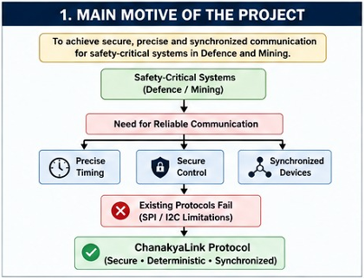

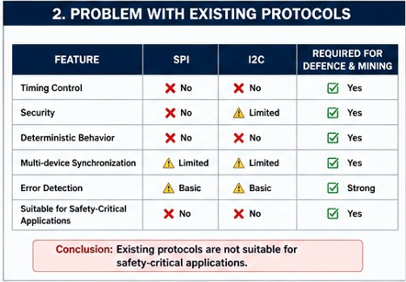

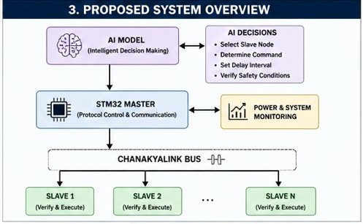

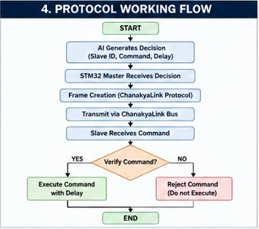

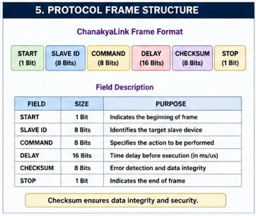

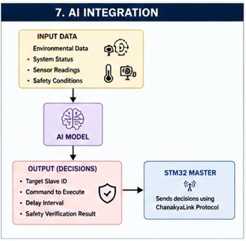

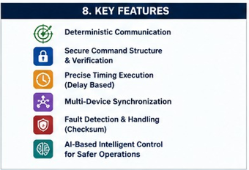

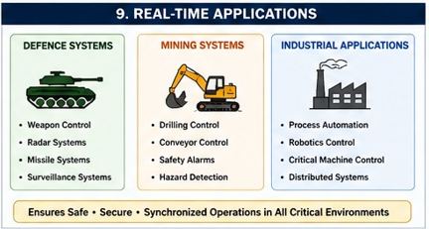

Frame Format:
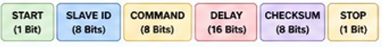

1.START (1 Bit)
- Indicates the beginning of the communication frame.
- Helps the receiver identify when a new packet starts.
- Used for synchronization between master and slave devices.
- Typical value may be logic 1.
2. SLAVE ID (8 Bits)
- Specifies the destination slave device.
- Each slave in the network is assigned a unique ID.
- Only the slave whose ID matches this field will process the command.
- Supports communication with up to 256 slave devices (2^8).
Example:
00000001 → Slave 1
00000010 → Slave 2
3. COMMAND (8 Bits)
- Contains the instruction that the slave must execute.
- Defines the operation to be performed.
Different binary values represent different commands.
4. DELAY (16 Bits)
- Specifies the time delay before executing the command.
- Enables deterministic and synchronized operation.
- Important in defence and mining systems where actions must occur at precise timings.
- Larger bit size allows a wide delay range (0–65535).

Example:
Delay = 1000 → Execute after 1000 clock cycles or milliseconds (depending on system design).
5. CHECKSUM (8 Bits)
- Used for error detection.
- Ensures that the received data is not corrupted during transmission.
- Receiver recalculates the checksum and compares it with the received value.
- If mismatch occurs, the frame is rejected.
This improves communication reliability in noisy environments.
6. STOP (1 Bit)
- Indicates the end of the communication frame.
- Helps the receiver know that the complete packet has been received.
- Prevents overlapping of consecutive frames.
- Typically represented by logic 0 or 1 depending on protocol design.
In Scope
• Master-slave communication management for embedded systems
• Deterministic and time-synchronized command execution
• Checksum-based error detection and frame validation.
• Multi-slave node communication and coordination
• Delay-based execution for safety-critical operations
• Real-time monitoring of communication status and command execution
• Fault detection, timeout handling, and retransmission support
• Secure command verification before execution
• Integration with embedded controllers, sensors, and actuators
• Communication logging and diagnostic monitoring
• Support for industrial and harsh environmental operation
• Configurable communication parameters and delay intervals
• Scalable slave device management and addressing
Out Scope
• Support for cloud-based communication systems
• Wireless communication technologies such as Wi-Fi, Bluetooth, or ZigBee
• Internet-based remote device management
• AI/ML-based predictive fault analysis
• Graphical mobile application support
• High-bandwidth multimedia data transmission
• Integration with non-embedded enterprise software platforms
• Blockchain-based communication security
• Real-time video or audio streaming applications
• Advanced cryptographic encryption mechanisms
• Support for heterogeneous operating systems and cloud providers
• WebSocket or internet protocol-based communication frameworks

Future Enhancements
1. Multi-Master Communication
Currently, the protocol mainly supports master-slave communication. Future versions can support multiple masters communicating on the same network with priority-based arbitration. This improves scalability and reliability in large defence or mining systems.

2.High-Speed Communication Architecture
To overcome the limitation of low data transfer speed, future versions of ChanakyaLink can use high-speed serial communication techniques, parallel data transfer, pipelined transmission, and optimized clock synchronization methods. The protocol can also be implemented on high-frequency FPGA architectures to achieve faster communication with lower latency.

3.AI-Based Fault Prediction
Integration with AI/ML algorithms can help:
- Predict communication failures
- Detect abnormal traffic patterns
- Identify faulty slave nodes
- Improve maintenance planning

Conclusion
ChanakyaLink is a secure and deterministic communication protocol specifically designed for defence and mining applications where reliable, synchronized, and safety-critical communication is essential. The protocol demonstrates efficient master-slave coordination, delay-based command execution, structured frame validation, and robust fault handling suitable for harsh industrial environments. Its major future challenges include enhancing communication security, scaling for large distributed embedded networks, and improving intelligent fault recovery mechanisms for highly critical real-time operations.

Project Type
VLSI Communication Protocol / Real-Time Industrial Communication System

